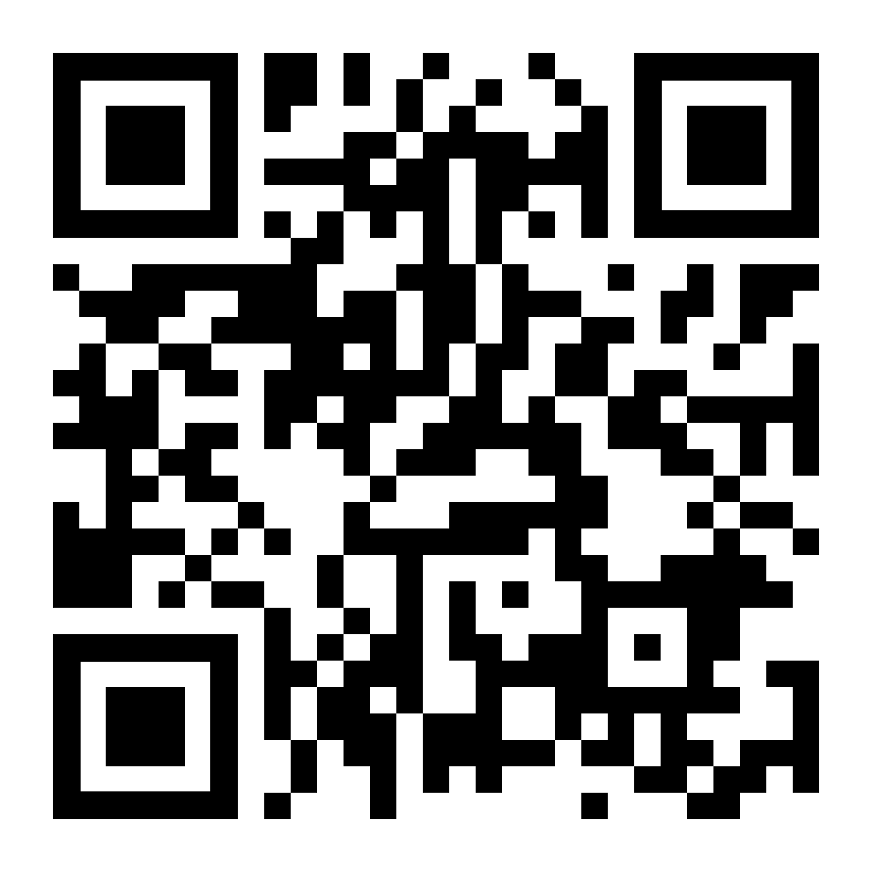

BRLA Membership Application (January-December 2024)

_________ Renewal _________ New Member

Name: ___________________________________________ Date: _____________________________

Home Address: ____________________________________ City/State ______________ Zip ________

Phone: _________________________ Place of Employment: _________________________________

Work Address: _____________________________________ City/State _____________ Zip _________

Work Phone: ____________________ Send mail to: _____ Work _____ Home

Email address: ______________________________________ (Note: BRLA Newsletter is sent via email)

***Please circle any information that you prefer to restrict.***

Please check the appropriate membership category:

________ Institutional - $30.00 ________ Student - $5.00

________ Regular - $20.00 ________ Retiree - $10.00

________ International - $10.00 ________ Support Staff - $10.00

***Optional Contribution to the BRLA Scholarship Fund (Amount) ____________________***

Are you interested in serving BRLA as a member of a committee or interest group? If so, please

indicate your area of interest:

______Advocacy/Publicity/Social Media ______ Children’s/YA Literature Study Group

______ Constitution/By-Laws ______ Del Norte Health Consortium

______ Continuing Education ______ Dia de los Niños Committee

______ Editorial ______ Downtown Librarians

______ Hospitality ______ Employment/Mentoring

______ Intellectual Freedom ______ Graduate Students

______ Intercultural ______ High School Librarians

______ New Members ______ International Libraries

______ Scholarship Committee ______ Las Cruces Librarians

______ Southwest Book Awards ______ Retired Librarians

**For additional information about Committees and/or Interest Groups, visit our website:** [**http://www.brla.info/**](http://www.brla.info/)

BRLA is a 501 (c)(3) federal income tax exempt organization. BRLA’s Tax ID # is 74-6090782

***BRLA membership dues are payable January 1st for the new calendar year. Make checks payable***

***to BRLA and mail to:***

***Sebastian Diaz***

***10805 Bywood***

***El Paso, TX 79935***